Section A – Entity Relationship Diagram (ERD)
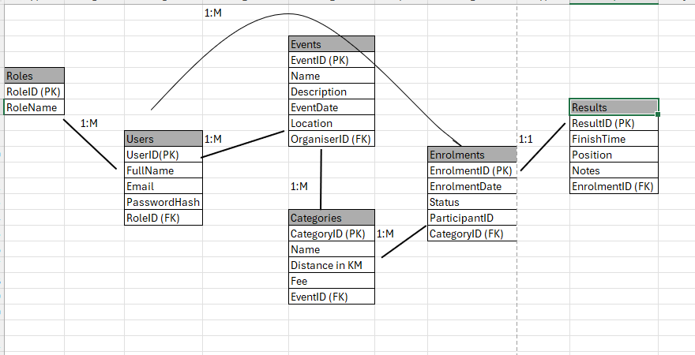
Section B – API Endpoint Plan

Authentication
HTTP Method | Route | Description | Role Required | Request Body | Expected Response
POST | /api/auth/register | Registers a new as an Organizer or Participant | None | { fullName, email, password, role} | 201 Created – new user id 400 Bad Request invalid/duplicate email
POST | /api/auth/login | Authenticated a user and returns a JWT token | None | { email, password} | 200 OK JWT token 401 Unauthorized invalid credentials

User Profile
HTTP Method | Route | Description | Role Required | Request Body | Expected Response
GET | /api/users/me | Returns the profile of the currently logged-in user | Any | None | 200 OK, user profile 401 Unauthorized
PUT | /api/users/me | Update the logged-in user’s own profile details | Any | {fullName, email } | 200 OK, updated profile 400 Bad Request

